**Project Report On**

**Online Auction Management System**

**In partial fulfillment for the award of the degree Of**

**BACHELOR OF COMPUTER APPLICATION [B.C.A]**

**Year 2024-2025**

**SUBMITTED BY: GUIDED BY:**

**_131 Arshit Kyada Prof. Dr. Piyush Arora**

**_161 Arshal Nakrani**

**066 Dharmik Ghevariya A.**

**BCA-6th SEMESTER**

**Submitted to:**



**SHRI SHAMBHUBHAI V. PATEL COLLEGE OF COMPUTER SCIENCE & BUSINESS**

**MANAGEMENT**

Affiliated to

**Veer Narmad South Gujarat University**

**INDEX**

|  |  |  |
| --- | --- | --- |
| **SR.NO** | **PARTICULAR** | **PAGE. NO** |
| **1** | **Introduction** |  |
|  | **1.1 Project Profile** | **3** |
| **2** | **System Environment** | **4** |
|  | **2.1 Hardware Used** | **4** |
|  | **2.2 Software Used** | **5** |
| **3** | **Problem Specification** | **6** |
|  | **3.1 Introduction, Objective and Purpose** | **6** |
|  | **3.2 System Model** | **8** |
|  | **3.3 Feasibility Study** | **I l** |
| **4** | **Risk Identification and Management** | **13** |
|  | **4.1 Risk Monitoring** | **13** |
| **5** | **Technology Used for Development** | **14** |
| **6** | **Planning** | **18** |
|  | **6.1 System Planning** | **18** |
|  | **6.2 Time Line Chart** | **19** |
| **7** | **System Analysis** | **20** |
|  | **7.1 Database Design** | **20** |
|  | **7.2 ER Diagram** | **21** |
|  | **7.3 Data Flow Diagram** | **22** |
|  | **7.4 Data Dictionary** | **31** |
| **8** | **Designing** | **35** |
|  | **8.1 User Interface** | **35** |
| **9** | **Testing** | **47** |
|  | **9.1 Software Testing** | **47** |
|  | **9.2 Unit Testing** | **48** |
|  | **9.3 System Testing** | **49** |
| **10** | **Reference** | **54** |

1. **Introduction**

* The **Online Auction Management System** is a web-based platform that enables users to bid on products and services securely and transparently.
* It provides a seamless environment for buyers and sellers to interact, ensuring fairness in transactions.
* As digital commerce grows, online auction platforms have become increasingly popular for their convenience and wide range of options.
* The system overcomes the limitations of traditional auction houses by allowing users to participate from anywhere with internet access.
* It serves a broad audience, including individuals and enterprises, and supports various categories such as antiques, electronics, and real estate, making it versatile for different needs.
* The main goal of the system is to make the auction process accessible and efficient.
* It simplifies the user experience with an intuitive interface, automated bidding, and scalability to handle a growing user base.
* Security and transparency are integral to its design, ensuring data protection and fair bidding practices.
* Key features include secure registration, role-based access for buyers and sellers, item listing with detailed descriptions and photos, and real-time bidding updates.
* Buyers can easily search for items using filters, while notifications and countdown timers enhance user engagement. Trusted payment gateways ensure secure transactions, and an administrative dashboard enables efficient management of auctions, users, and reports.
* The system offers extensive benefits, including global reach, time savings, and reduced physical constraints.
* It lowers costs by eliminating the need for physical venues and provides analytics for data-driven decisions.
* By leveraging advanced technology, the Online Auction Management System delivers a user-friendly, efficient, and competitive platform, transforming the auction process in the digital age.
  1. **Project Profile:-**

|  |  |  |
| --- | --- | --- |
| 1 | Project Title | Online Auction management system |
| 2 | Developed By | Arshal Nakrani Arshit Kyada  Dharmik Ghevariya |
| 3 | Guidence By | …………………. |
| 4 | Back End | Php,Xampp , MySql |
| 5 | Front End | HTML,CSS,BOOTSTRAP,  ,JAVASCRIPT |
| 6 | Operating System | Microsoft Windows |
| 7 | College Name | **SHRI SHAMBHUBHAI V. PATEL COLLEGE** |

**Key Objectives:-**

* + - **Convenience and Accessibility**: The system ensures users can participate in auctions from the comfort of their homes or offices using any internet-enabled device.
    - **Transparency**: All bidding activity is recorded and visible, fostering trust between buyers and sellers.
    - **Efficiency**: Automation of the auction process reduces manual intervention, speeding up transactions and reducing errors.
    - **Global Reach**: By removing geographical restrictions, the platform allows international participation, ensuring maximum exposure for auctioned items.

**Features of the System:-**

* + - **User Registration and Authentication**: Secure account creation for buyers and sellers, including identity verification.
    - **Product Listing**: Sellers can easily upload product details, images, and auction terms.
    - **Real-Time Bidding**: A dynamic interface for live bidding with real-time updates.
    - **Auction Scheduling**: The system allows scheduling of auctions with specified start and end times.
    - **Notifications**: Instant notifications for bid updates, auction results, and other activities.
    - **Automated Bidding**: Support for proxy bidding, where users set a maximum bid amount, and the system bids on their behalf.
    - **Payment Integration**: Secure payment gateways for transaction processing.
    - **Analytics and Reporting**: Comprehensive reports for sellers to track bids, sales, and revenue.

**Benefits of the System:-**

* + - **Cost Efficiency**: Reduces overhead costs compared to physical auctions.
    - **Enhanced Participation**: Attracts a wider audience through global accessibility.
    - **Streamlined Processes**: Simplifies auction management for sellers and bidders.
    - **Scalability**: Supports multiple simultaneous auctions and thousands of users.

1. **SYSTEM ENVIRONMENT**
   1. **Hardware Required**
      * **Hardware Requirement :-**

|  |  |
| --- | --- |
| **RAM** | **4 GB** |
| **Any** | **20 GB & Above** |
| **Processor** | **Intel core i5** |

* 1. **Software Required**
     + **Software Requirement :-**

|  |  |
| --- | --- |
| **Platform** | **Microsoft Windows 10** |
| **Browser** | **Google Chrome** |
| **Front End** | **Html ,Css,Javascriopt** |
| **Back End** | **PHP ,MYSQL** |
| **Server** | **XAMPP** |
| **Other Tools** | **Edraw Max** |

1. **PROBLEM SPECIFICATION**
   1. **Introduction & Objective and Purpose :-**

* In the digital age, the way goods and services are traded has evolved dramatically. Auctions, which have traditionally been conducted in physical locations, are now increasingly shifting to online platforms.
* This transition has unlocked new opportunities by eliminating geographical limitations and offering a more accessible, efficient, and transparent environment for buyers and sellers.
* The Online Auction Management System is a web-based platform that facilitates the auctioning process by allowing sellers to list their products or services and enabling buyers to bid on them in real-time.
* The system is designed to handle various types of auctions, including timed auctions and live auctions, and supports features such as automated bidding, payment processing, and notifications. By leveraging modern technology, this system aims to provide a secure, scalable, and user-friendly solution that meets the needs of today's competitive market.
* This document outlines the features, objectives, and purpose of the Online Auction Management System, highlighting its role in modern commerce.

**Objective :-**

The primary objective of the Online Auction Management System is to create a robust and scalable platform that facilitates seamless auctions for both buyers and sellers. Key objectives include:

* **Streamline the Auction Process**: Automate and simplify the process of listing items, bidding, and payment settlement to ensure a smooth user experience.
* **Enhance Accessibility**: Provide a global platform that eliminates geographical barriers, allowing users from anywhere in the world to participate in auctions.
* **Ensure Transparency**: Build trust among users by offering a transparent bidding process with real-time updates and clear information about products and bids.
* **Increase Efficiency**: Minimize manual intervention through automated features like bidding history tracking, notifications, and analytics reporting.
* **Provide Security**: Protect user data and transactions with advanced security measures, including encryption, secure payment gateways, and user authentication mechanisms.
* **Promote Fair Competition**: Create a level playing field where buyers can compete fairly for items, ensuring the highest possible value for sellers.

**Purpose**

The purpose of the **Online Auction Management System** is to revolutionize the traditional auction process by utilizing digital technology to address its limitations and enhance its capabilities. The system is designed to:

* **Empower Sellers**: Provide sellers with an efficient way to showcase their products or services to a global audience, maximizing visibility and revenue potential.
* **Offer Convenience to Buyers**: Enable buyers to participate in auctions from the comfort of their homes or workplaces, with flexible options like real-time or automated bidding.
* **Foster Trust and Reliability**: Build a secure and transparent environment where users feel confident in the fairness of the auction process.
* **Reduce Costs**: Eliminate the need for physical auction venues, reducing operational costs for organizers while offering affordable solutions for participants.
* **Enhance Market Reach**: Expand the scope of auctions to include international participants, creating a competitive marketplace and ensuring better outcomes for all parties.
* **Facilitate Real-Time Interactions**: Enable live auctions with instant updates to ensure participants are always informed of current bid statuses.
  1. **System Model**

**Incremental Model**

* Incremental model: Incremental model is an evolution of waterfall model. The system is designed, implemented, integrated and tested as a series of incremental model. This model combines elements of linear sequential model with the iterative method.
* Incremental Model is a process of software development where requirements are broken down into multiple standalone modules of software development cycle.
* Each iteration passes through the requirements, design, coding and testing phases. And each subsequent release of the system adds function to the previous release until all designed functionality has been implemented.
* In incremental model the whole requirement is divided into various builds. Multiple development cycles take place here, makingthe life cycle a “multi waterfall” cycle. Cycles are divided up into smaller, more easily

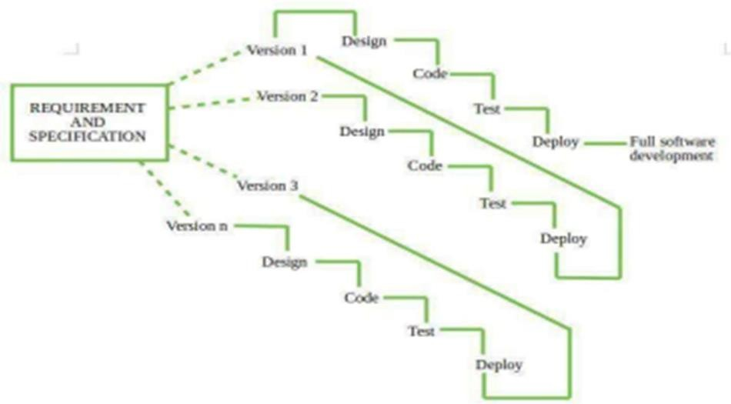

* + In this model, each module passes through the requirements, design, implementation and testing phases. A working version of software is produced during the first module, so you have working software early on during the software life cycle. Each subsequent release of the module adds function to the previous release. The process continues till the complete system is achieved.
  + The system is put into production when the first increment is delivered. The first increment is often a core product where the basic requirements are addressed, and supplementary features are added in the next increments. Once the core product is analyzed by the client, there is plan development for the next increment.

**Characteristics of Incremental Process Model:**

* + System development is divided into several smaller projects.
  + To create a final complete system, partial systems are constructed one after the other.
  + Priority requirements are addressed first.
  + The requirements for that increment are frozen once they are created.

**Advantages:**

* + System is developed and delivered in increments after establishing an overall architecture.
  + Users may experiment with the delivered increments while others are being developed.
  + Early increments can be implemented with fewer people.
  + Generates working software quickly and early during the software life cycle. Easier to manage risk because risky piece are identified and handled during its iteration.

**Disadvantages:**

* + Problems may arise pertaining to system architecture because not all requirements are gathered up front for entire software life cycle.
  + Resulting cost may exceed the cost of the organization.
  + It takes a lot of time and effort to fix an issue in one unit if it needs to be corrected in all the units.

**Feasibility Study**

1. **Technical Feasibility**

The system can be developed using modern technologies like React, Django, and cloud hosting platforms such as AWS. Real-time bidding, secure payment gateways, and user authentication can be efficiently implemented, making the project technically feasible.

1. **Economic Feasibility**

The system's costs include development, hosting, and maintenance, which can be offset by revenue from transaction fees, premium listings, and ads. The platform has strong profitability potential and a manageable break-even timeline.

1. **Operational Feasibility**

The platform is designed to be user-friendly, with intuitive navigation for buyers and sellers. With proper training and support, minimal operational staff is required to maintain the system globally.

1. **Legal Feasibility**

The system complies with data protection laws (e.g., GDPR) and auction regulations. Proper terms and conditions, along with tax compliance, ensure legal safety for both the business and users.

1. **Schedule Feasibility**

Using the incremental development model, the system can be developed in manageable phases within a reasonable timeline. Agile methodology ensures flexibility and timely delivery.

1. **RISK IDENTIFICATION & MANAGEMENT**

**Risk Monitoring:-**

* Risk monitoring is the process of continuously assessing and tracking identified risks to ensure that mitigation plans are effective and to make adjustments as necessary.
* It involves tracking the evolution of risks, updating the risk register, and providing timely reports to stakeholders.

**Key Components:-**

* **Risk Category**: The type of risk (e.g., financial, operational, environmental).
* **Risk**: The specific event or situation that poses a potential threat.
* **Probability**: The likelihood of the risk occurring (often rated on a scale such as low, medium, high).
* **Risk Factor**: The level of impact or consequence if the risk occurs, often related to the severity or scale of damage.

**Risk Monitoring Table:-**

|  |  |  |  |
| --- | --- | --- | --- |
| **Risk Category** | **Risk** | **Probability** | **Risk Factor** |
| Financial | Exchange rate fluctuations | High | Major impact on costs and revenue |
| Operational | Equipment failure | Medium | Operational delay, production halt |
| Environmental | Natural disaster (earthquake) | Low | Severe damage, business interruption |
| Technical | Cybersecurity breach | Medium | Data loss, reputation damage |

1. **TECHNOLOGY USED FOR DEVELOPMENT**
   1. **Front End**
      * **HTML (Hypertext Markup Language)**

* HTML stands for Hyper Text Markup Language, which is the most widely used language on Web to develop web pages. HTML was created by Berners-Lee in late 1991 but "HTML 2.0" was the first standard HTML specification which was published in 1995. HTML 4.01 was a major version of HTML and it was published in late 1999. Though HTML 4.01 version is widely used but currently we are having HTML-5 version which is an extension to HTML 4.01, and this version was published in 2012.
* Hypertext refers to the way in which Web pages (HTML documents) are linked together. Thus, the link available on a webpage is called Hypertext
* A s its name suggests, HTML is a Markup Language which means you use HTML to simply "mark-up" a text document with tags that tell a Web browser how to structure it to display..
* Originally, HTML was developed with the intent of defining the structure of documents like headings, paragraphs, lists, and so forth to facilitate the sharing of scientific information between researchers.
* Now, HTML is being widely used to format web pages with the help of different tags available in HTML language.
* HTML5 (Hypertext Markup Language 5) is . It was the fifth and final major HTML version that is now a retired World Wide Web Consortium (W3C) recommendation.
* The current specification is known as the HTML Living Standard.
* One significant aspect of HTML5 is its emphasis on providing native support for multimedia, eliminating the need for third-party plugins. The introduction of new semantic elements allows developers to create clearer and more meaningful structures, enhancing accessibility and search engine optimization.
  + - **CSS (Cascading Style Sheet)**
* CSS is used to control the style of a web document in a simple and easy way.
* CSS is the acronym for "Cascading Style Sheet". This tutorial covers both the versions CSS1, CSS2 and CSS3, and gives a complete understanding of CSS, starting from its basics to advanced concepts.
* CSS handles the look and feel part of a web page. Using CSS, you can control the color of the text, the style of fonts, the spacing between paragraphs, how columns are sized and laid out, what background images or colors are used, layout designs, variations in display for different devices and screen sizes as well as a variety of other effects.
* CSS is easy to learn and understand but it provides powerful control over the presentation of an HTML document. Most commonly, CSS is combined with the markup languages HTML or XHTML.

**Advantages of CSS**

CSS saves time

* + You can write CSS once and then reuse same sheet in multiple HTML pages. You can define a style for each HTML element and apply it to as many Web pages as you want.

Pages load faster

* + If you are using CSS, you do not need to write HTML tag attributes every time. Just write one CSS rule of a tag and apply it to all the occurrences of that tag. So less code means faster download times.

Easy maintenance

* + To make a global change, simply change the style, and all elements in all the web pages will be updated automatically.

Superior styles to HTML

* + CSS has a much wider array of attributes than HTML, so you can give a far better look to your HTML page in comparison to HTML attributes.

Multiple Device Compatibility

* + Style sheets allow content to be optimized for more than one type of device. By using the same HTML document, different versions of a website can be presented for handheld devices such as PDAs and cell phones or for printing

Global web standards

* + Now HTML attributes are being deprecated and it is being recommended to use CSS. So it’s a good idea to start using CSS in all the HTML pages to make them compatible to future browsers.
    - **JavaScript**
      * javaScript is a dynamic computer programming language. It is lightweight and most commonly used as a part of web pages, whose implementations allow client- side script to interact with the user and make dynamic pages. It is an interpreted programming language with object-oriented capabilities
      * JavaScript was first known as LiveScript, but Netscape changed its name to JavaScript, possibly because of the excitement being generated by Java. JavaScript made its first appearance in Netscape 2.0 in 1995 with the name LiveScript. The generalpurpose core of the language has been embedded in Netscape, Internet Explorer, and other web browsers.
      * JavaScript is a lightweight, interpreted programming language.
      * Designed for creating network-centric applications.
      * Complementary to and integrated with Java.
      * Complementary to and integrated with HTML.

Purpose

* + - * JavaScript was initially developed to make web pages interactive and dynamic.

**Type**

* High-level, interpreted programming language.

Usage

* + Both client-side (browsers) and server- side (Node.js).

Primitive Types

* + String, Number, Boolean, Null, Undefined, Symbol.
    - **Bootstrap**
      * Bootstrap is a free and open-source tool collection for creating responsive websites and web applications. It is the most popular HTML, CSS, and JavaScript framework for developing responsive, mobile-first web sites. It solves many problems which we had once, one of which is the cross-browser compatibility issue.
      * Nowadays, the websites are perfect for all the browsers (IE, Firefox and Chrome) and for all sizes of screens (Desktop, Tablets, Phablets, and Phones). All thanks to Bootstrap developers -Mark Otto and Jacob Thornton of Twitter, though it was later declared to be an opensource project.
      * Bootstrap 5 is the newest version of [Bootstrap,](https://www.w3schools.com/bootstrap/default.asp) which is the most popular HTML, CSS, and JavaScript framework for creating responsive, mobile-first websites.
      * Bootstrap 5 is completely free to download and use!
      * Here are some key aspects of Bootstrap

1. **Responsive Design**
2. **Grid System**
3. Utilities
4. Typography

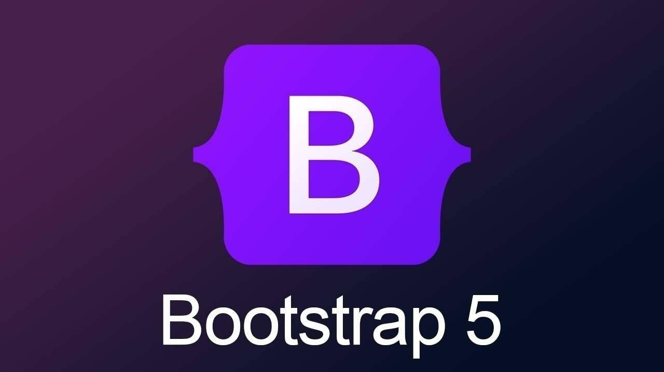

* + Jquery
    - jQuery is a fast and concise JavaScript Library created by John Resig in 2006 with a nice motto: Write less, do more. jQuery simplifies HTML document traversing, event handling, animating, and Ajax interactions for rapid web development. jQuery is a JavaScript toolkit designed to simplify various tasks by writing less code.
* DOM manipulation
  + The jQuery made it easy to select DOM elements, negotiate them and modifying their content by using cross-browser open source selector engine called Sizzle
* Event handling
  + The jQuery offers an elegant way to capture a wide variety of events, such as a user clicking on a link, without the need to clutter the HTML code itself ith event handlers
* AJAX Support
  + The jQuery helps you a lot to develop a responsive and feature rich site using AJAX technology.
* Animations
  + The jQuery comes with plenty of built-in animation effects which you can use in your websites
* **Lightweight**
  + The jQuery is very lightweight library - about 19KB in size (Minified and gripped).
* Cross browser Support
  + The jQuery has cross browser support, and works well in IE 6.0+, FF 2.0+, Safari 3.0+, Chrome and Opera 9.0+
  1. **Back End**
     + Php
       - PHP (Hypertext Preprocessor) is a widely-used server-side scripting language designed for web development. Initially created in 1994 by Rasmus Lerdorf, PHP has evolved into a powerful and versatile language that facilitates the creation of dynamic and interactive web pages.
       - It was originally created by Danish-Canadian programmer Rasmus Lerdorf in 1993 and released in 1995. The PHP reference implementation is now produced by the PHP Group.
* Server-Side Scripting
  + PHP operates on the server side, generating HTML content dynamically before it is sent to the user's browser. This enables developers to create dynamic web pages and applications, handling tasks such as form processing, database interactions, and server-side logic.
* **Syntax and Integration:**
  + PHP code is embedded within HTML, making it easy to integrate with existing web pages. The PHP code is enclosed in <?php ... ?> tags, allowing seamless transitions between PHP and HTML.
* **MS SQL SERVER 2008**
  + SQL Server is a relational database management system (RDBMS) developed by Microsoft. It is primarily designed and developed to compete with MySQL and Oracle database. It supports both 32-bit and 64-bit environments. In this website it’s used to store data in nvdb database.
  + SQL Server 2008 is a relational database management system (RDBMS) developed by Microsoft. It was released as part of the Microsoft SQL Server product line and is an important version in the evolution of SQL Server. Here are some key aspects of SQL Server 2008
  + SQL Server 2008 was released by Microsoft in August 2008.
  + SQL Server 2008 had several editions, including Enterprise, Standard, Workgroup, Web, and Express. Each edition had different features and capabilities, catering to various usage scenarios.
  + SQL Server Management Studio (SSMS) was the primary tool for managing and administering SQL Server 2008 databases.

.

1. **Planning**
   1. **System Planning**

The system follows the Agile methodology, which ensures iterative development, flexibility, and adaptability based on user feedback. The development is divided into multiple sprints, where each sprint focuses on completing specific features. Regular stand-up meetings, sprint reviews, and retrospectives help track progress and ensure smooth development.

**Key Planning Considerations:**

1. **Requirement Gathering:**
   * Identify the needs of users, such as auction creation, bidding, and payment integration.
   * Conduct surveys and interviews to collect user feedback and refine system requirements.
   * Define functional and non-functional requirements to outline the scope of the project.
2. **Resource Allocation:**
   * Assign developers, testers, and designers based on project complexity.
   * Ensure balanced workload distribution to maintain productivity and efficiency.
   * Utilize project management tools like Jira or Trello for tracking task assignments and progress.
3. **Risk Assessment:**
   * Identify possible risks such as security concerns, data breaches, server downtimes, and scalability issues.
   * Develop risk mitigation strategies, including backup systems, disaster recovery plans, and security audits.
   * Establish a monitoring system for early detection and resolution of risks.
4. **Development Phases:**
   * Clearly define milestones and deliverables for each sprint.
   * Break down development into phases, including prototyping, core feature implementation, and enhancements.
   * Ensure collaboration between frontend, backend, and database teams to streamline development.
5. **Testing and QA:**
   * Implement continuous testing throughout the development cycle to identify and resolve bugs early.
   * Conduct unit testing, integration testing, system testing, and user acceptance testing.
   * Use automated testing tools to enhance efficiency and accuracy.
6. **Deployment Strategy:**
   * Implement CI/CD pipelines for smooth updates without downtime.
   * Deploy the system in a staging environment before production rollout.
   * Monitor performance and user feedback post-deployment to make necessary optimizations.
7. **Scalability Planning:**
   * Ensure the system can handle growing numbers of users and auctions by utilizing cloud-based infrastructure.
   * Implement database sharding and indexing to optimize query performance.
   * Use load balancing techniques to distribute traffic and prevent server overload.
8. **Performance Optimization:**
   * Implement caching mechanisms such as Redis or Memcached to enhance response times.
   * Optimize database queries and API calls to reduce latency.
   * Conduct regular performance testing and profiling to identify bottlenecks.
   1. **Time Line Chart**

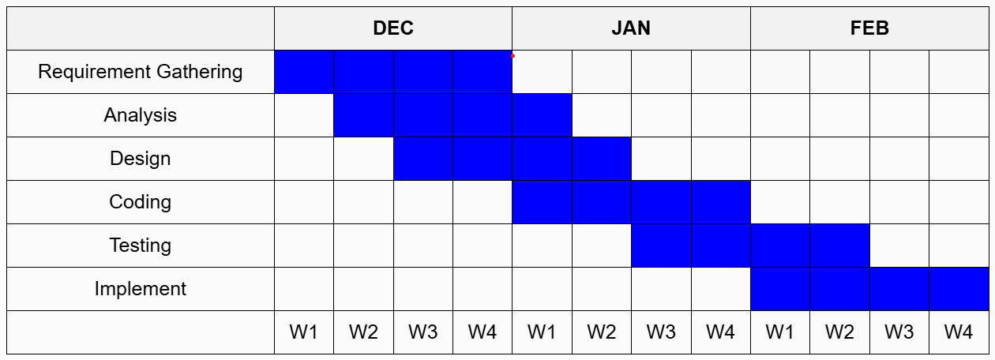

1. **SYSTEM ANALYSIS**
   1. **Database Design Data table:-**
2. **Table structure for table user table**

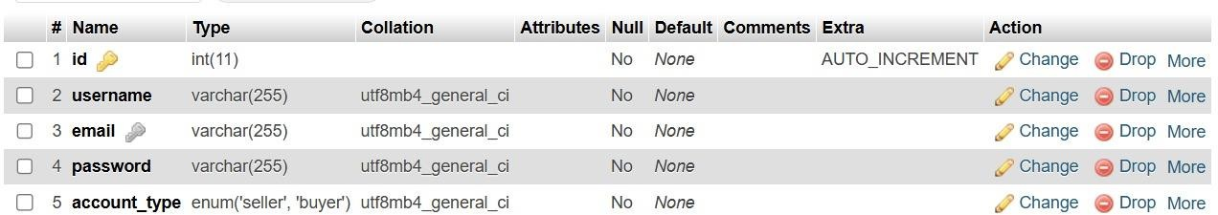

1. **Table structure for Products:-**

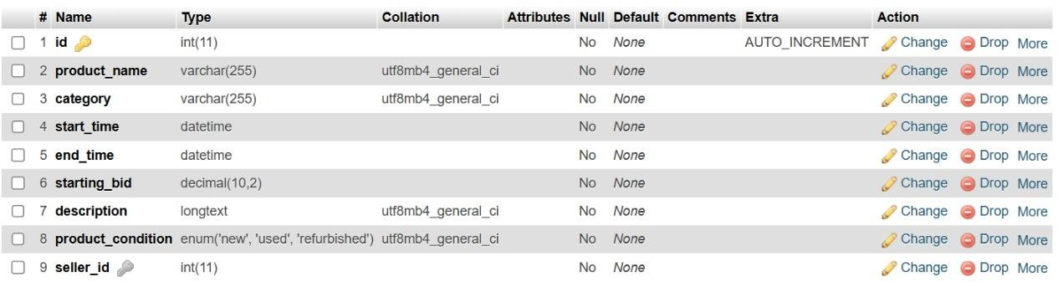

1. **Table structure for Table Products Image:-**

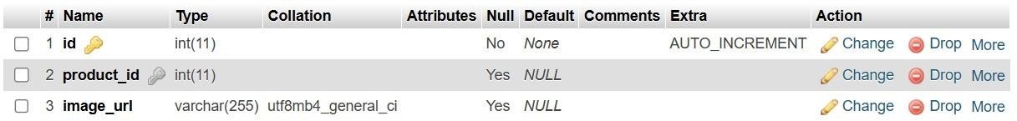

1. **Table structure for Table Bid:-**

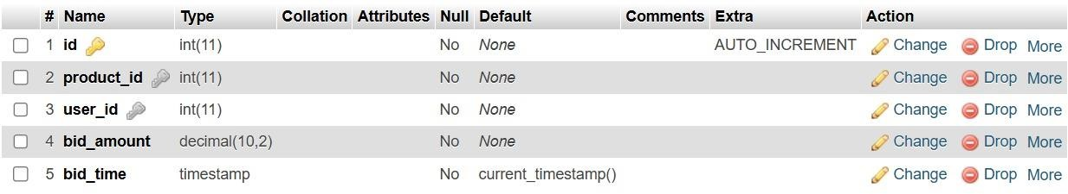

1. **Table structure for Table Payment:-**

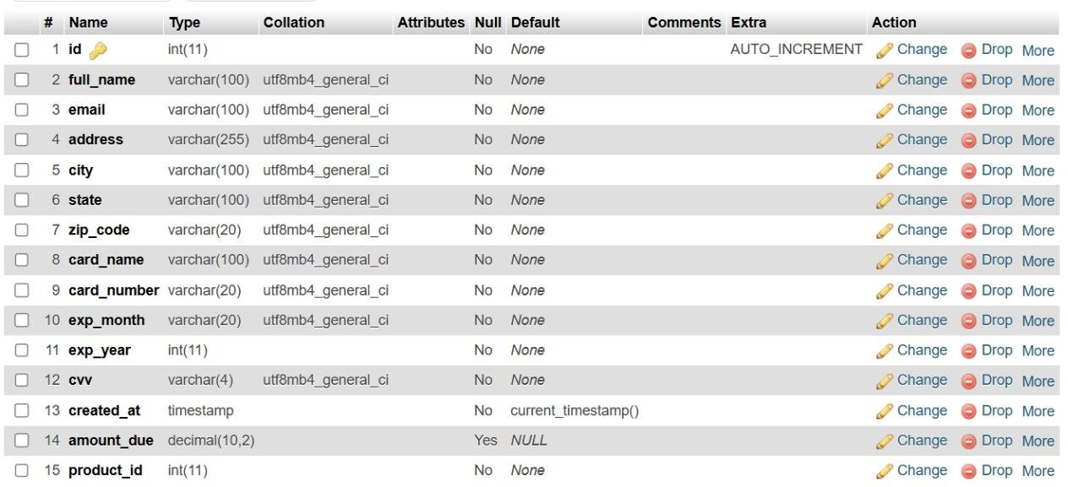

1. **Table structure for Table Contactus:-**

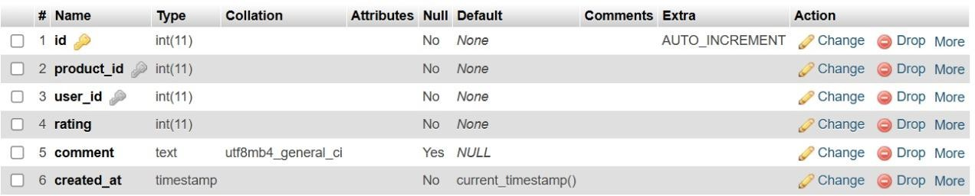

1. **Table structure for Table Reviews:-**



1. **Table structure for Table Withdrawals:-**

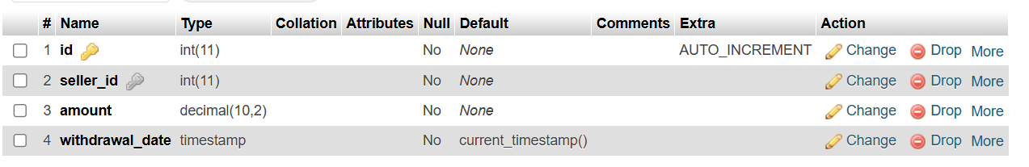

* 1. **Entity Relationship Diagram (ER Diagram)**

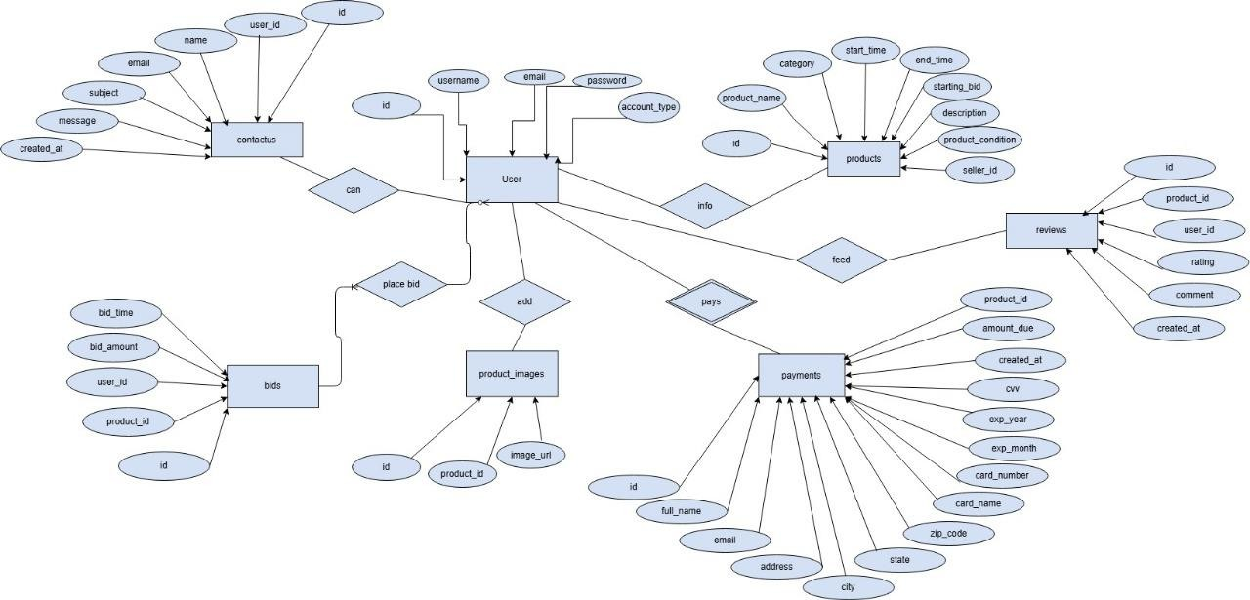

* 1. **DATA FLOW DIAGRAM (DFD)**

**Context level;-**

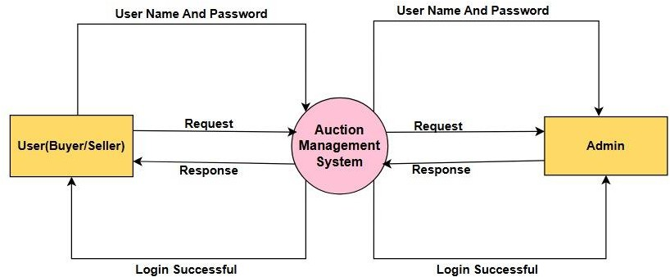

**First level DFD (Admin side);-**

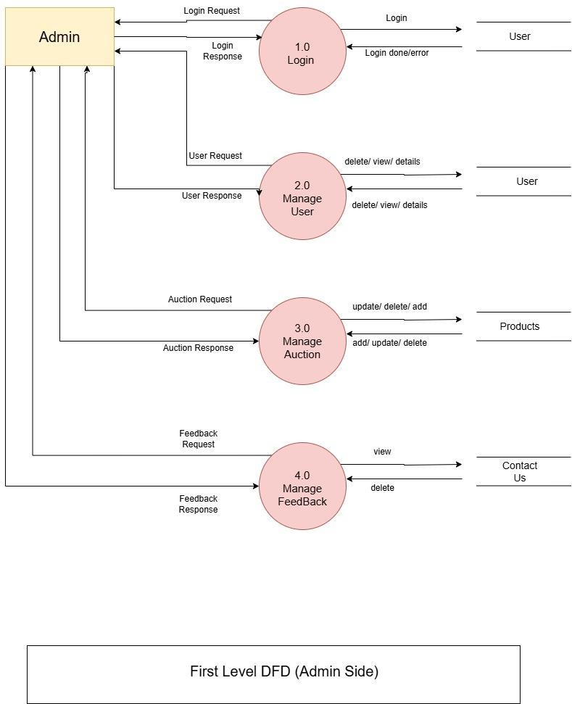

**Second level DFD (Admin side);-**

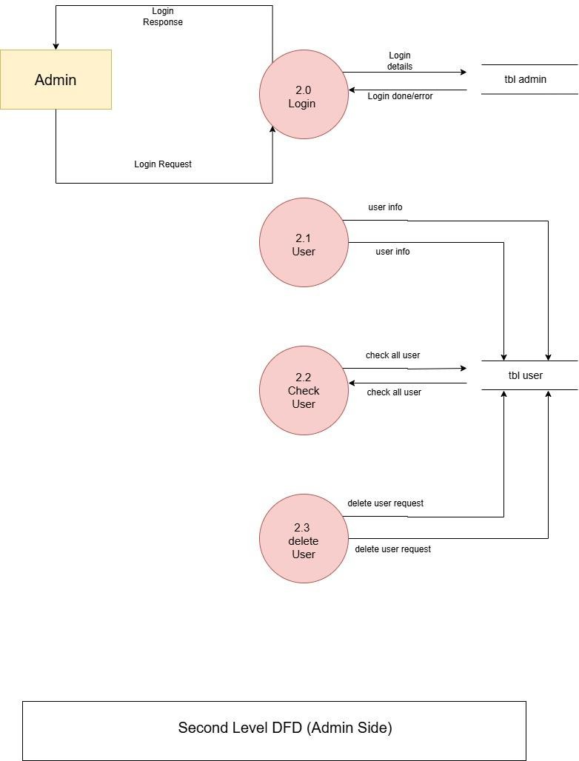

**First level DFD (User side);-**

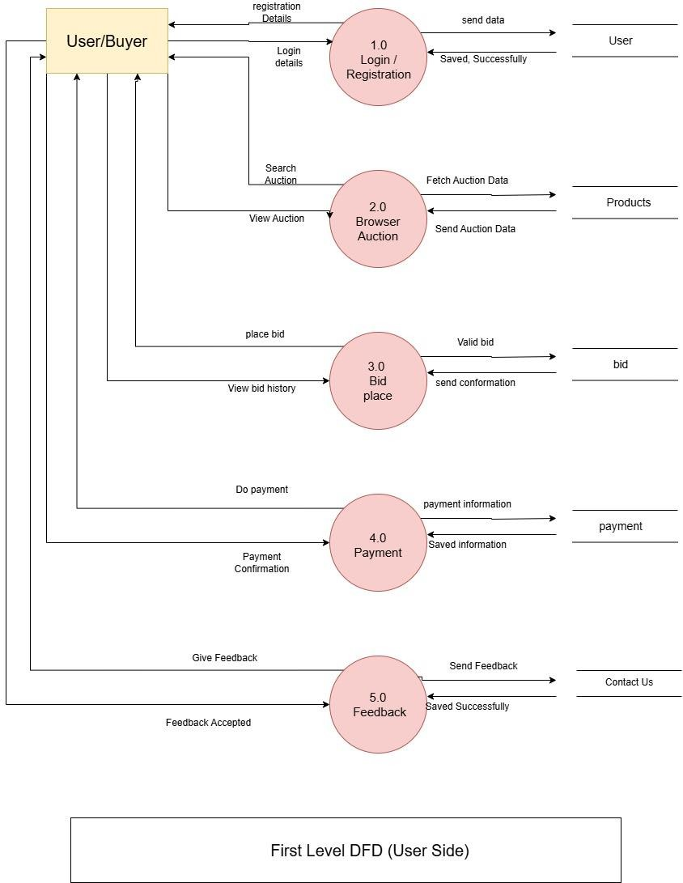

**Second level DFD (User side);-**

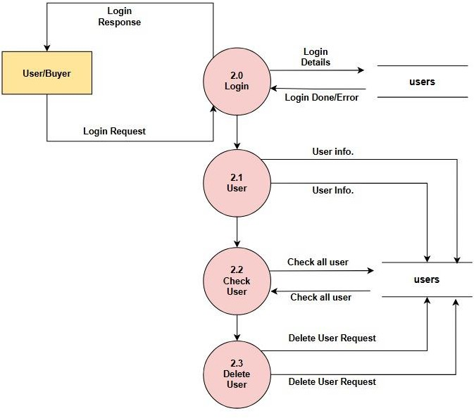

**First level DFD (User/seller side);-**

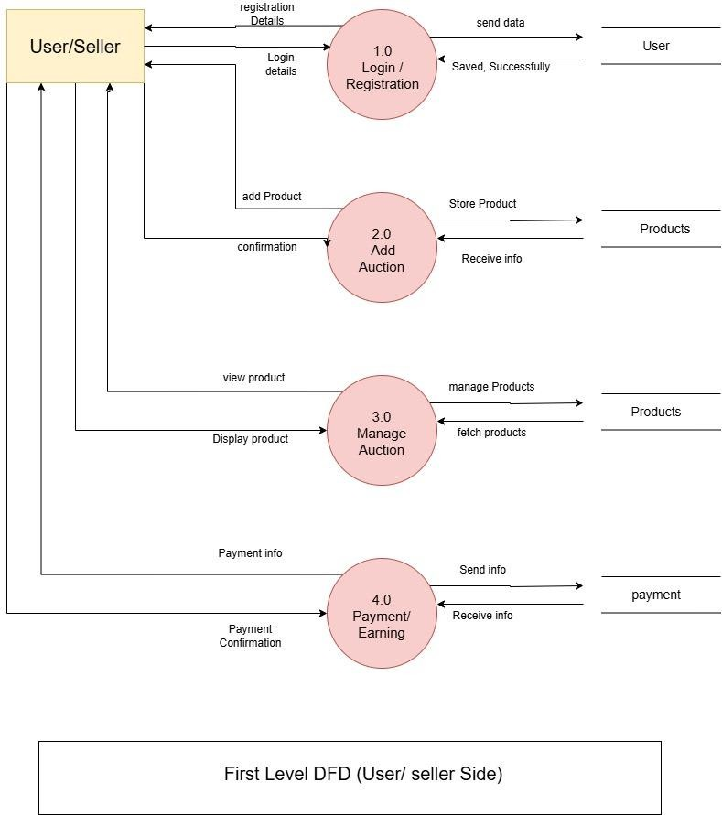

* 1. **Data Dictionary User:-**

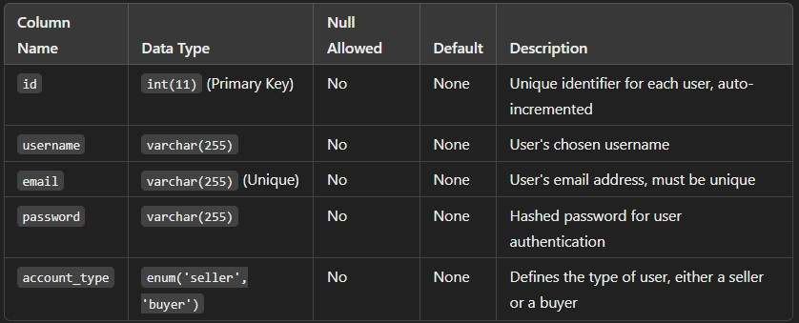

**Products:-**

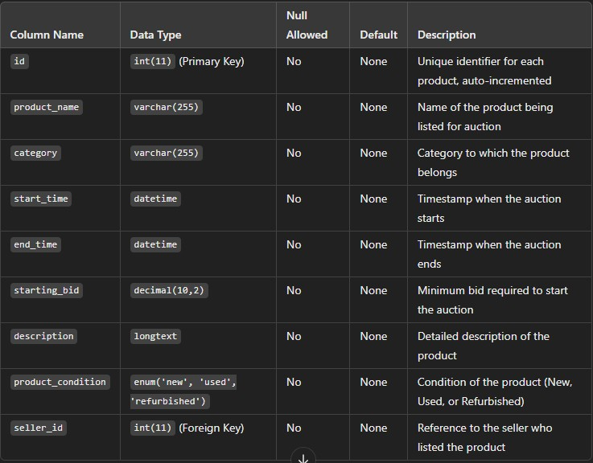

**Products_Images:-**

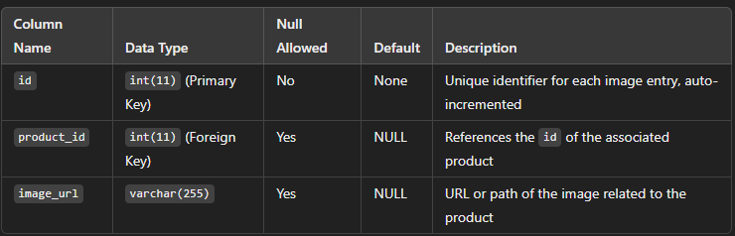

**Bid:-**

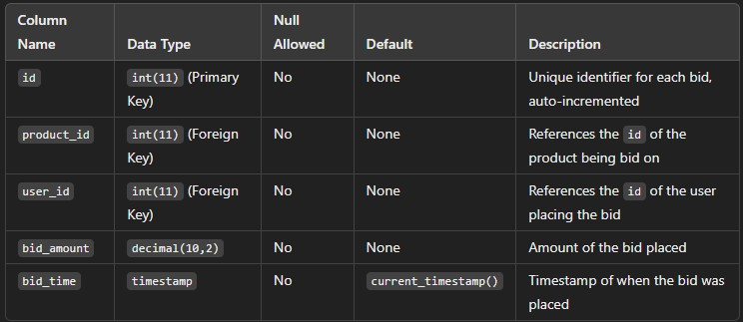

**Payments:-**

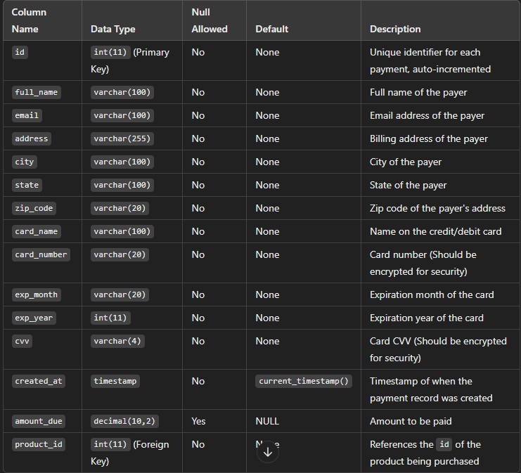

**Contact Us:-**

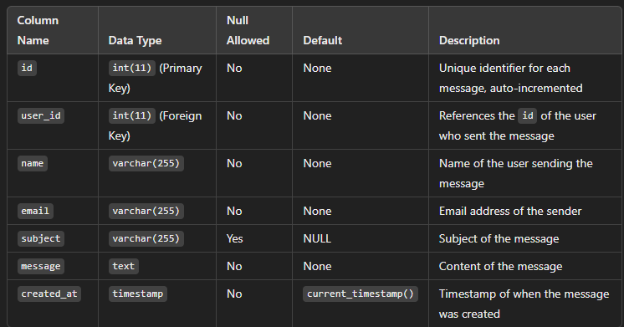

**Reviews:-**

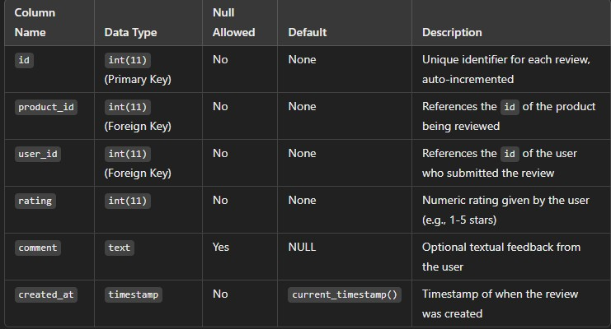

1. **Designing**
   1. **User Interface Home Page:-**

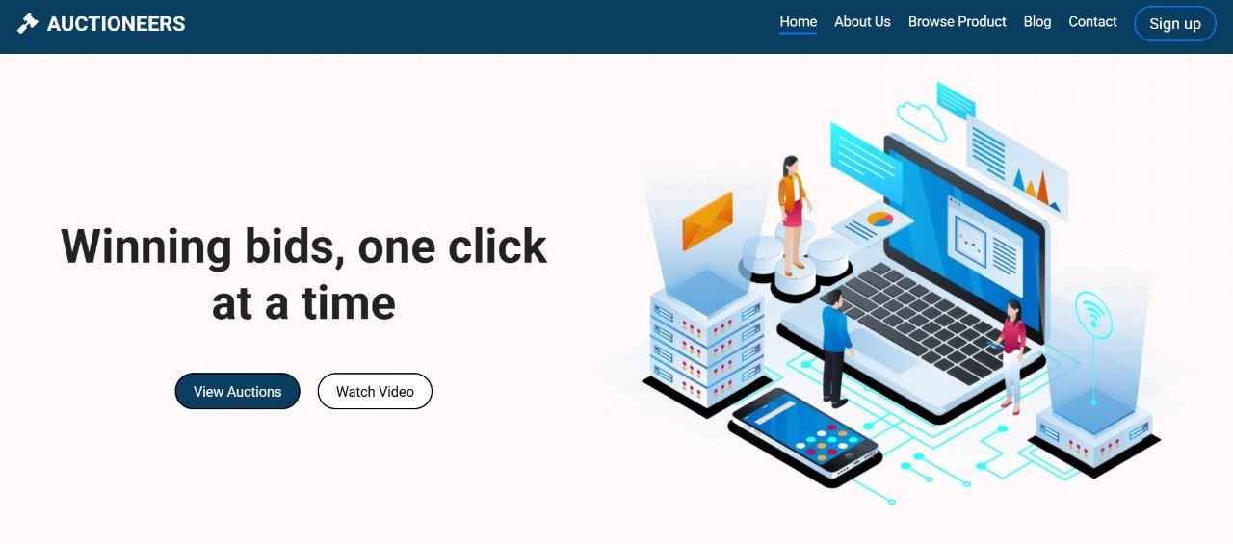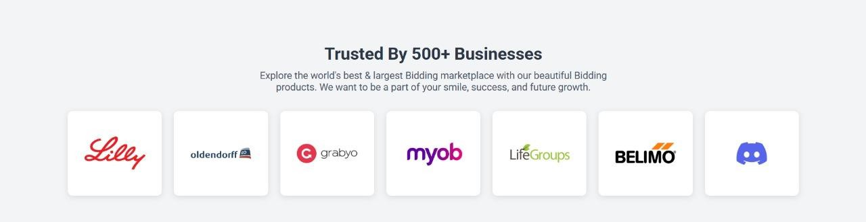

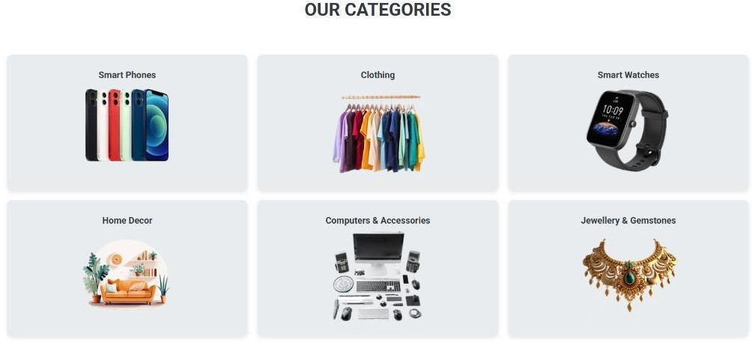

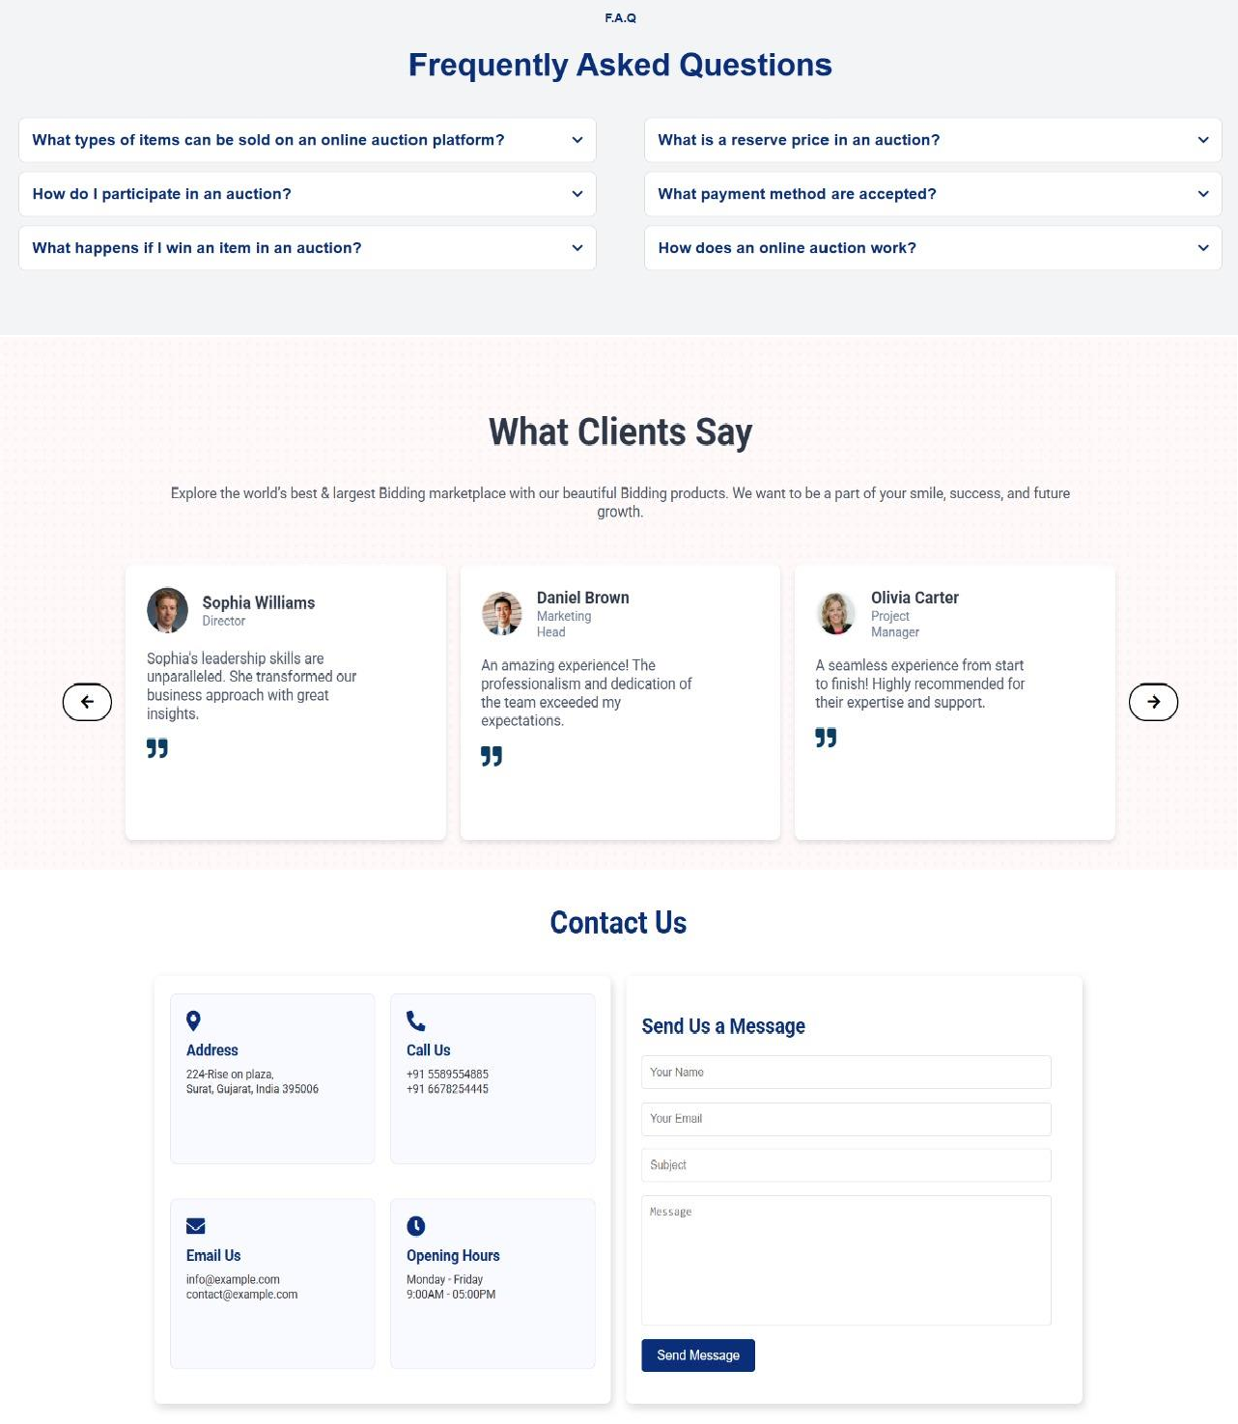

Sign Up Page:-

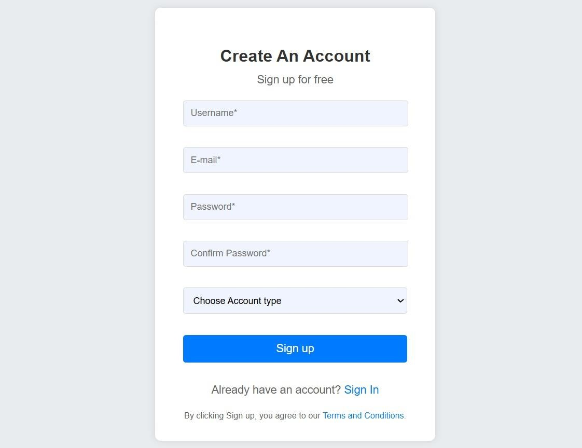

Sign In Page :

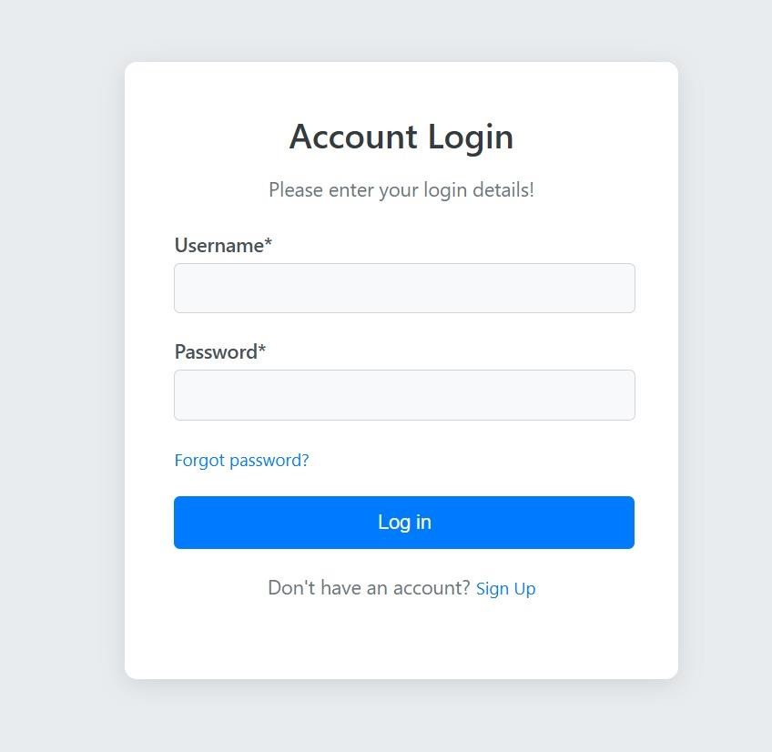

About Us Page:-

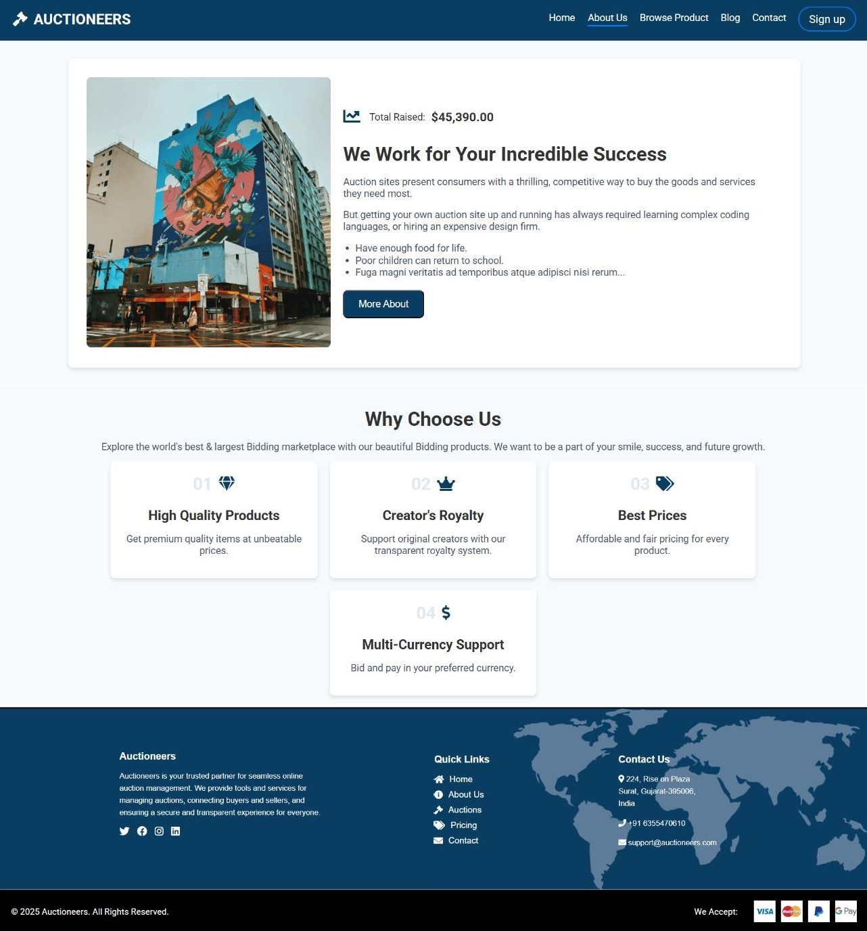

Browse Product:-

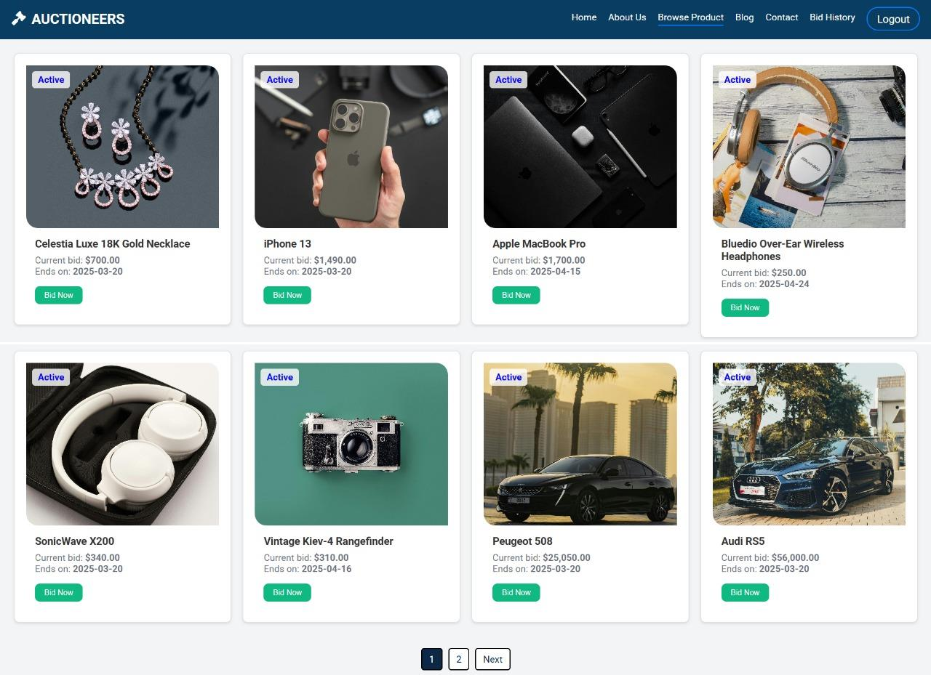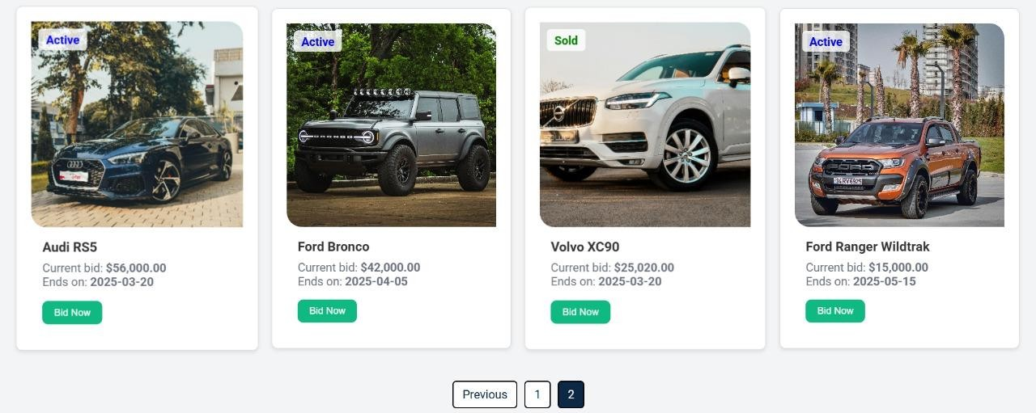

Product Detail Page:-



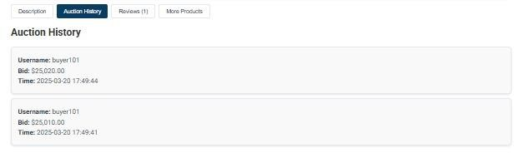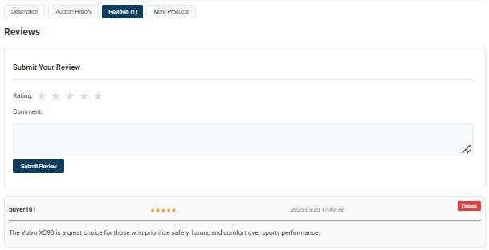



My Bid History:-

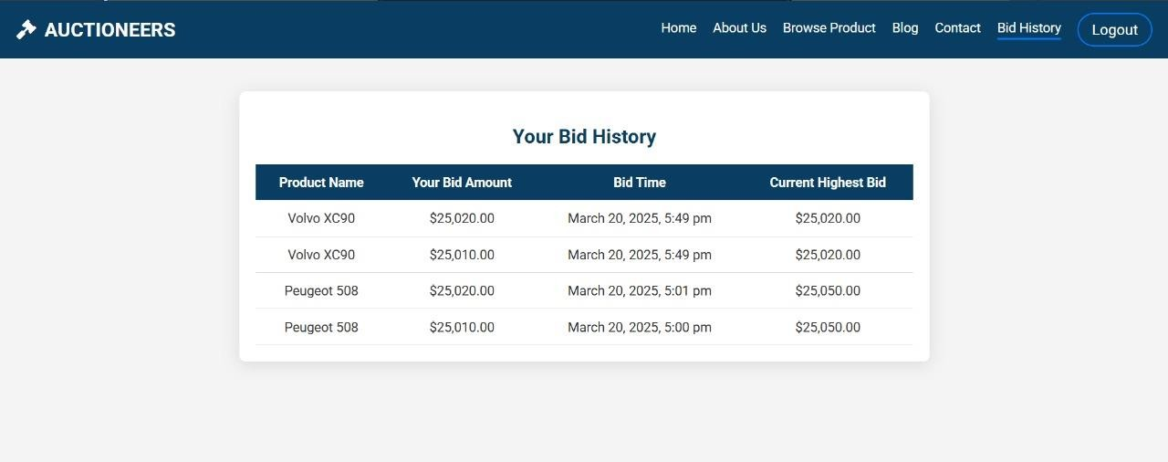

Blog Page:-



**Payment Page:-**

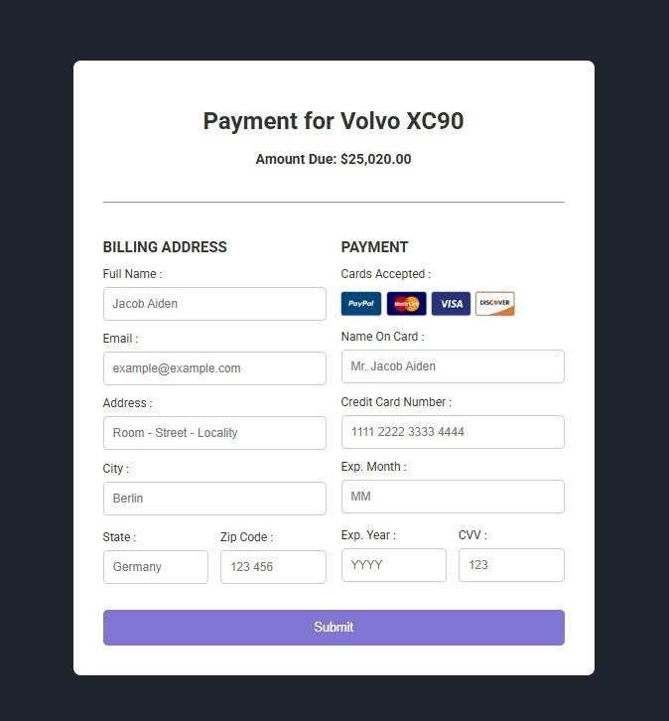

**Seller Dashbord:-**

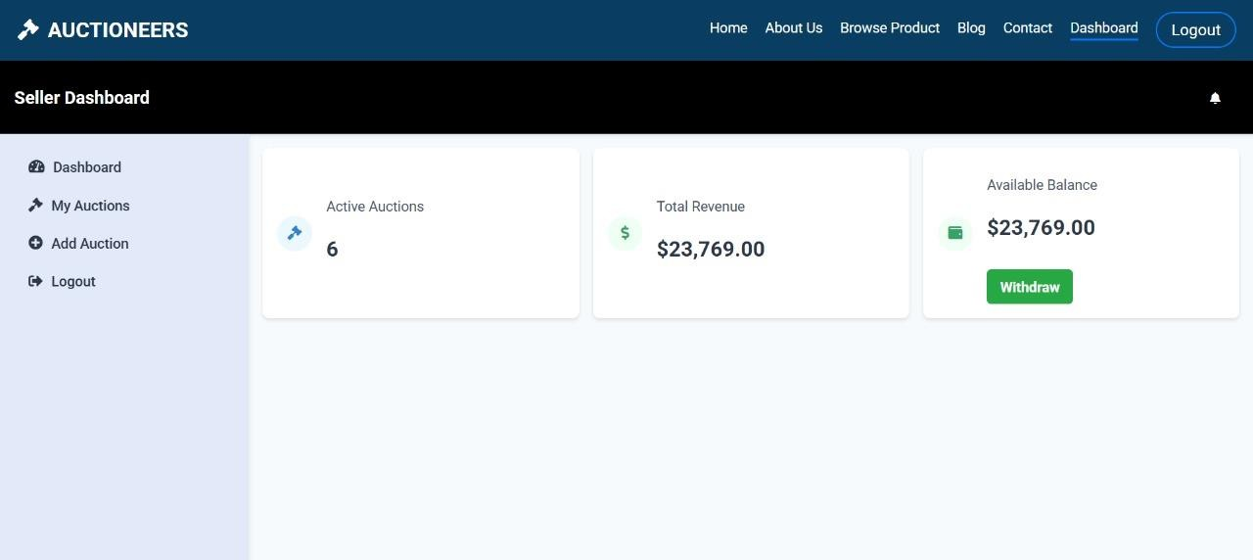

**My auction page:-**

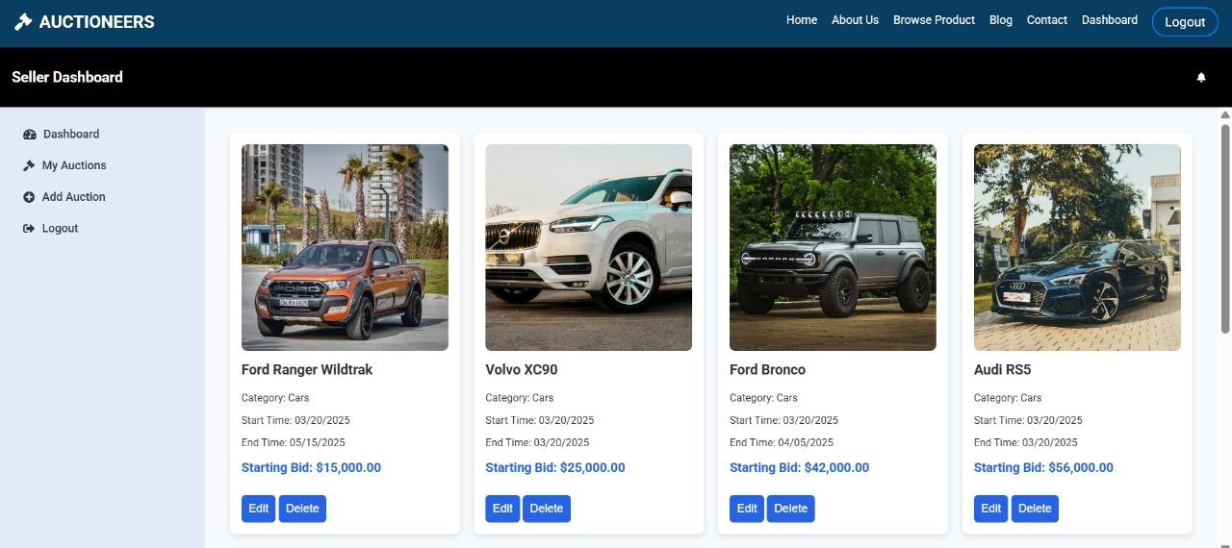

**Add Product Page:-**

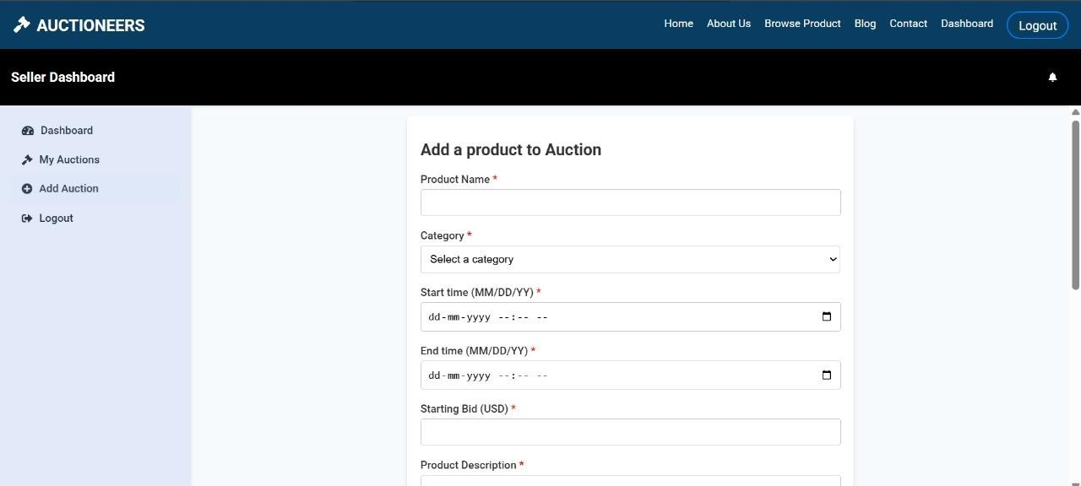

**Withdrawal page:-**

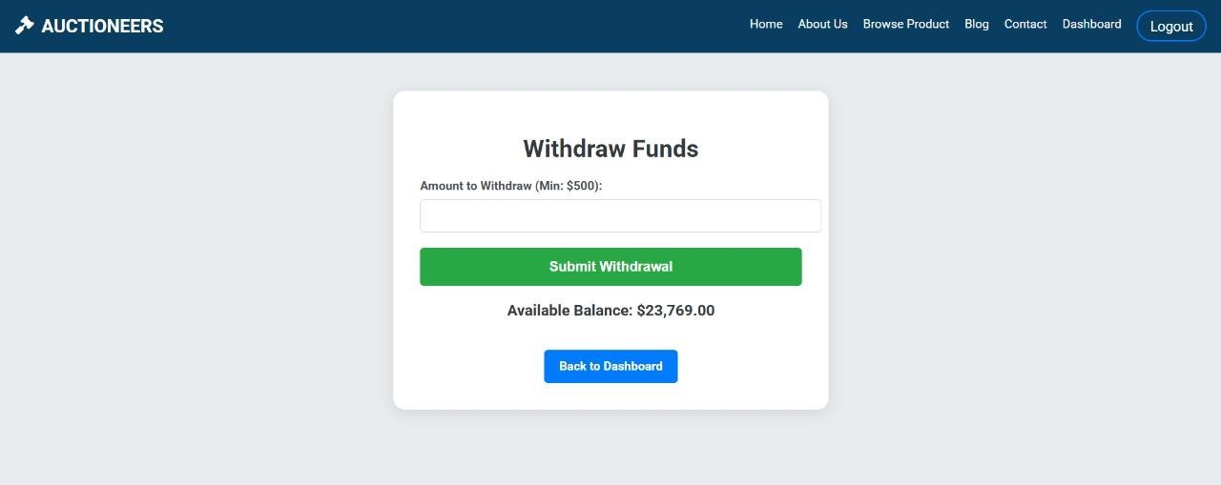

**Admin Side:-**

**Admin dashboard page:-**

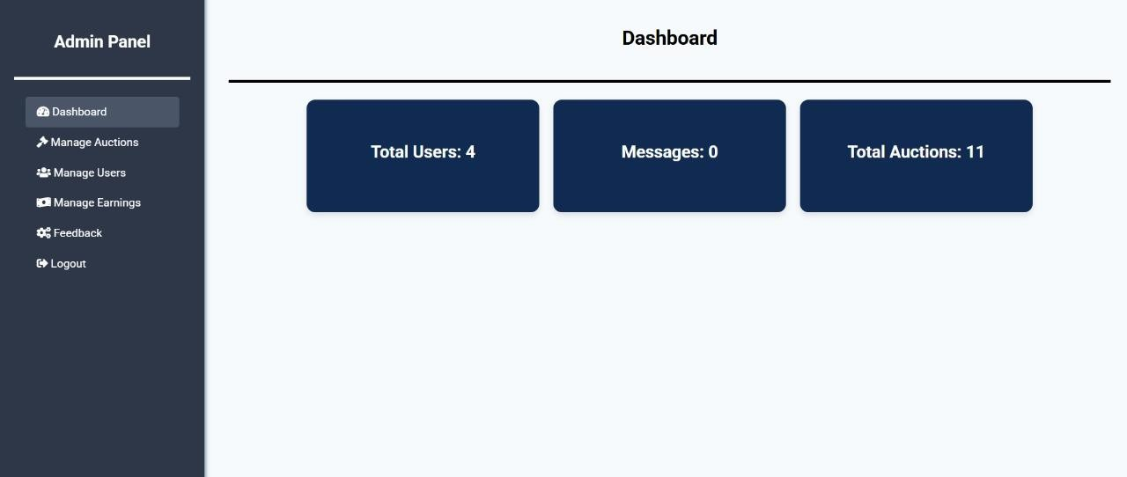

**Manage Auctions Page:-**

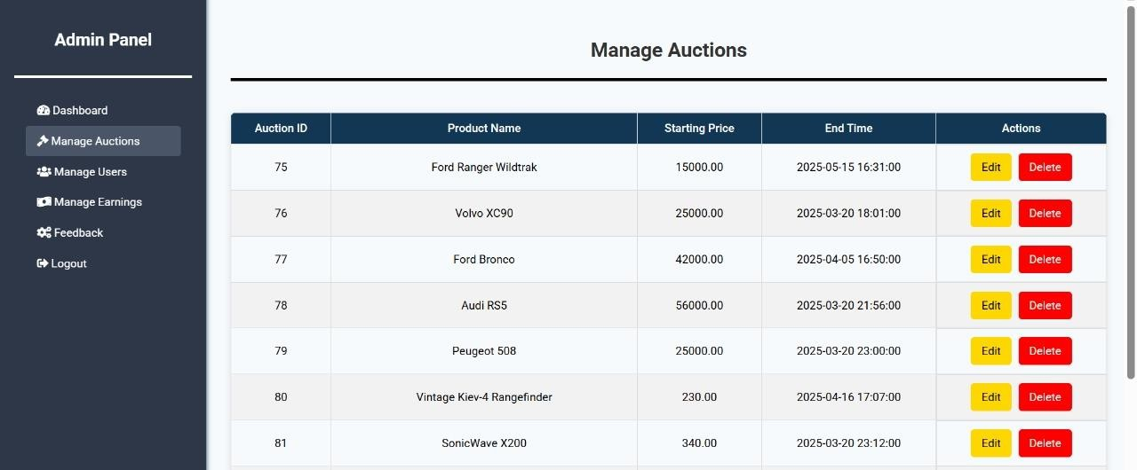

**Manage Users Page:-**

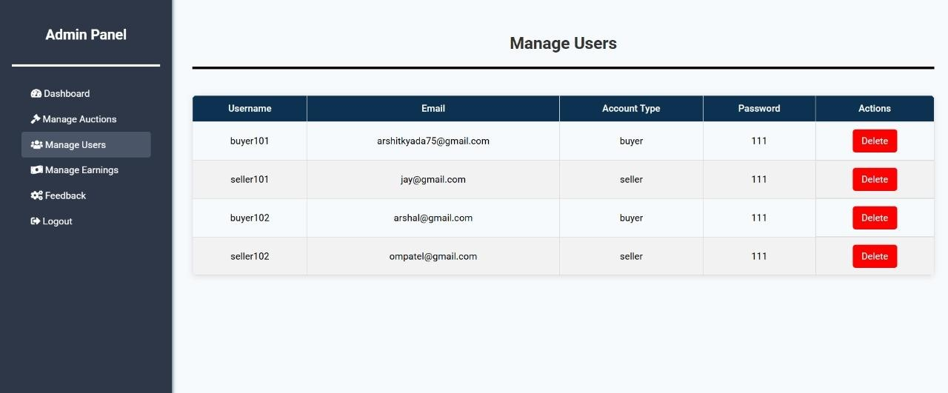

**Manage Earnings Page:-**

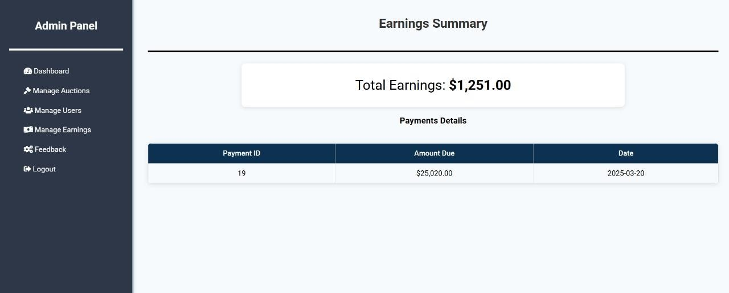

**Feedback Page:-**

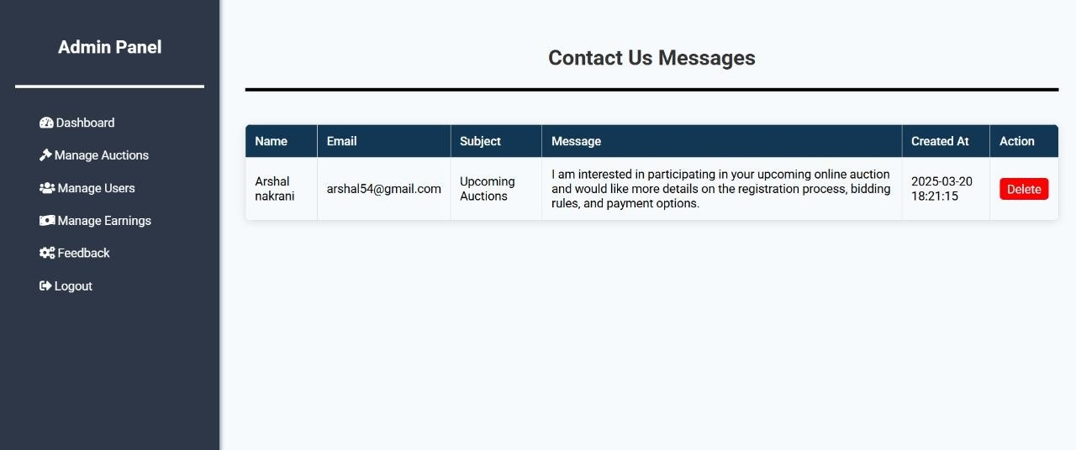

1. **Testing**

An Online Auction Management System requires rigorous testing to ensure smooth operation, security, and a seamless user experience. This includes software testing, unit testing, and system testing, each addressing different aspects of the system's functionality.

1. **Software Testing**

Software testing is the process of verifying that the auction system functions correctly, meets business requirements, and is free from critical defects. It includes functional and non-functional testing.

**Functional Testing**

Functional testing ensures that all key features of the auction system, such as bidding, payment processing, user authentication, and auction expiration, work correctly. It covers:

* + User registration and login verification
  + Auction creation and management
  + Placing bids and auto-bidding functionality
  + Payment gateway integration and transaction validation
  + Notifications via email, SMS, or push alerts

**Non-Functional Testing**

Non-functional testing evaluates system aspects such as performance, security, and usability. Key areas include:

* + Performance testing to check how the system handles multiple bidders simultaneously
  + Security testing to prevent SQL injection, cross-site scripting (XSS), and unauthorized access
  + Usability testing to ensure a smooth user experience and intuitive navigation

Both **manual** and **automated testing** methods are used in the process, depending on the complexity of the test cases and system architecture

1. **Unit Testing**

Unit testing focuses on testing individual components of the auction system in isolation. This type of testing ensures that the smallest units of code, such as functions, classes, and methods, perform as expected before being integrated with other parts of the system.

**Key Unit Testing Scenarios**

1. **User Authentication**
   * Verify that users can log in with valid credentials and are blocked with incorrect ones.
   * Ensure that password hashing and session management work securely.
2. **Bid Placement**
   * Test if users can place bids and if the bid amount updates correctly in the system.
   * Validate that only authenticated users can participate in auctions.
3. **Auction Timer and Expiry**
   * Confirm that auctions automatically close at the specified time and prevent further bids.
   * Check if expired auctions correctly notify participants of the final result.
4. **Auto-Bid Functionality**
   * Validate that when a user enables auto-bidding, their bid automatically increases up to their maximum set limit.
   * Ensure proper priority handling when multiple users have auto-bid enabled.
5. **Payment Processing**
   * Verify that payments are processed correctly through integrated payment gateways.
   * Test refund scenarios in case of unsuccessful transactions.
6. **User Registration and Profile Management**
   * Ensure that required fields (name, email, password) are validated before account creation.
   * Test password reset functionality to confirm security and reliability.

**Tools for Unit Testing**

* **JUnit** (for Java-based testing)
* **PyTest** (for Python-based testing)
* **Mocha/Chai** (for JavaScript testing)
* **Selenium WebDriver** (for UI-based unit testing)

Unit testing is typically performed by developers using automated frameworks to ensure quick validation of code before moving to integration testing.

1. **System Testing**

System testing evaluates the **entire auction system** as a fully integrated application. This ensures that all components work together seamlessly and meet business and user requirements.

**Key System Testing Scenarios**

1. **Auction Lifecycle Validation**
   * Test an auction from creation to completion, ensuring all steps function correctly.
   * Verify that users can browse and participate in ongoing auctions without issues.
2. **Multiple User Bidding**
   * Simulate multiple users placing bids on the same auction to test concurrency and system response time.
   * Ensure that real-time updates work correctly without bid conflicts.
3. **Auction Expiration Handling**
   * Confirm that no bids are accepted after an auction reaches its set end time.
   * Test system behavior when extending an auction due to last-minute bidding (if applicable).
4. **Bid Conflict Resolution**
   * Verify that when two users bid at the same time, the system correctly determines the winning bid based on auction rules.
   * Ensure that users receive real-time notifications when they are outbid.
5. **Session Management and Security**
   * Test automatic session timeout after user inactivity for security compliance.
   * Ensure that users are redirected to login when attempting to access restricted pages after session expiration.
6. **Email & SMS Notifications**
   * Validate that users receive timely notifications for auction events, including:
     + Successful bid confirmation
     + Outbid alerts
     + Auction ending reminders
     + Payment confirmation
7. **Payment and Transaction Handling**
   * Test whether payments are processed successfully and that users receive transaction receipts.
   * Verify refund mechanisms in case of failed payments or auction cancellations.
8. **Error Handling & System Recovery**
   * Simulate system crashes and unexpected failures to ensure data is preserved after recovery.
   * Check that the system logs errors properly and notifies administrators for critical issues.

10 Reference

❖ [https://app.diagrams.net](https://app.diagrams.net/)

❖ [https://www.w3schools.com](https://www.w3schools.com/)

❖ <https://www.javatpoint.com/>

❖ <https://openai.com/blog/chatgpt>

❖ [https://github.com](https://github.com/)